Create an Image

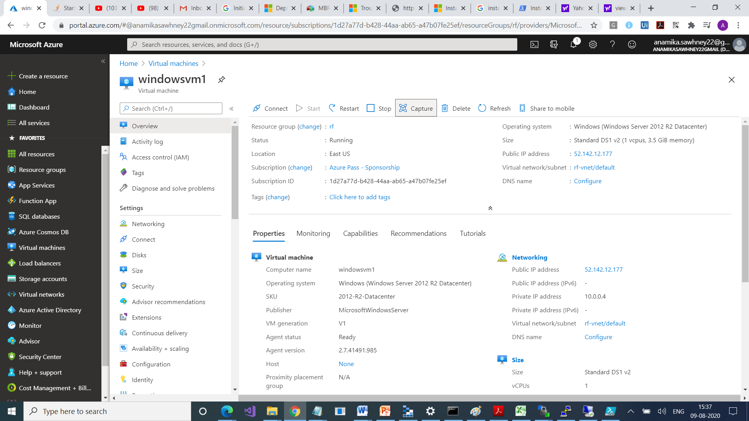

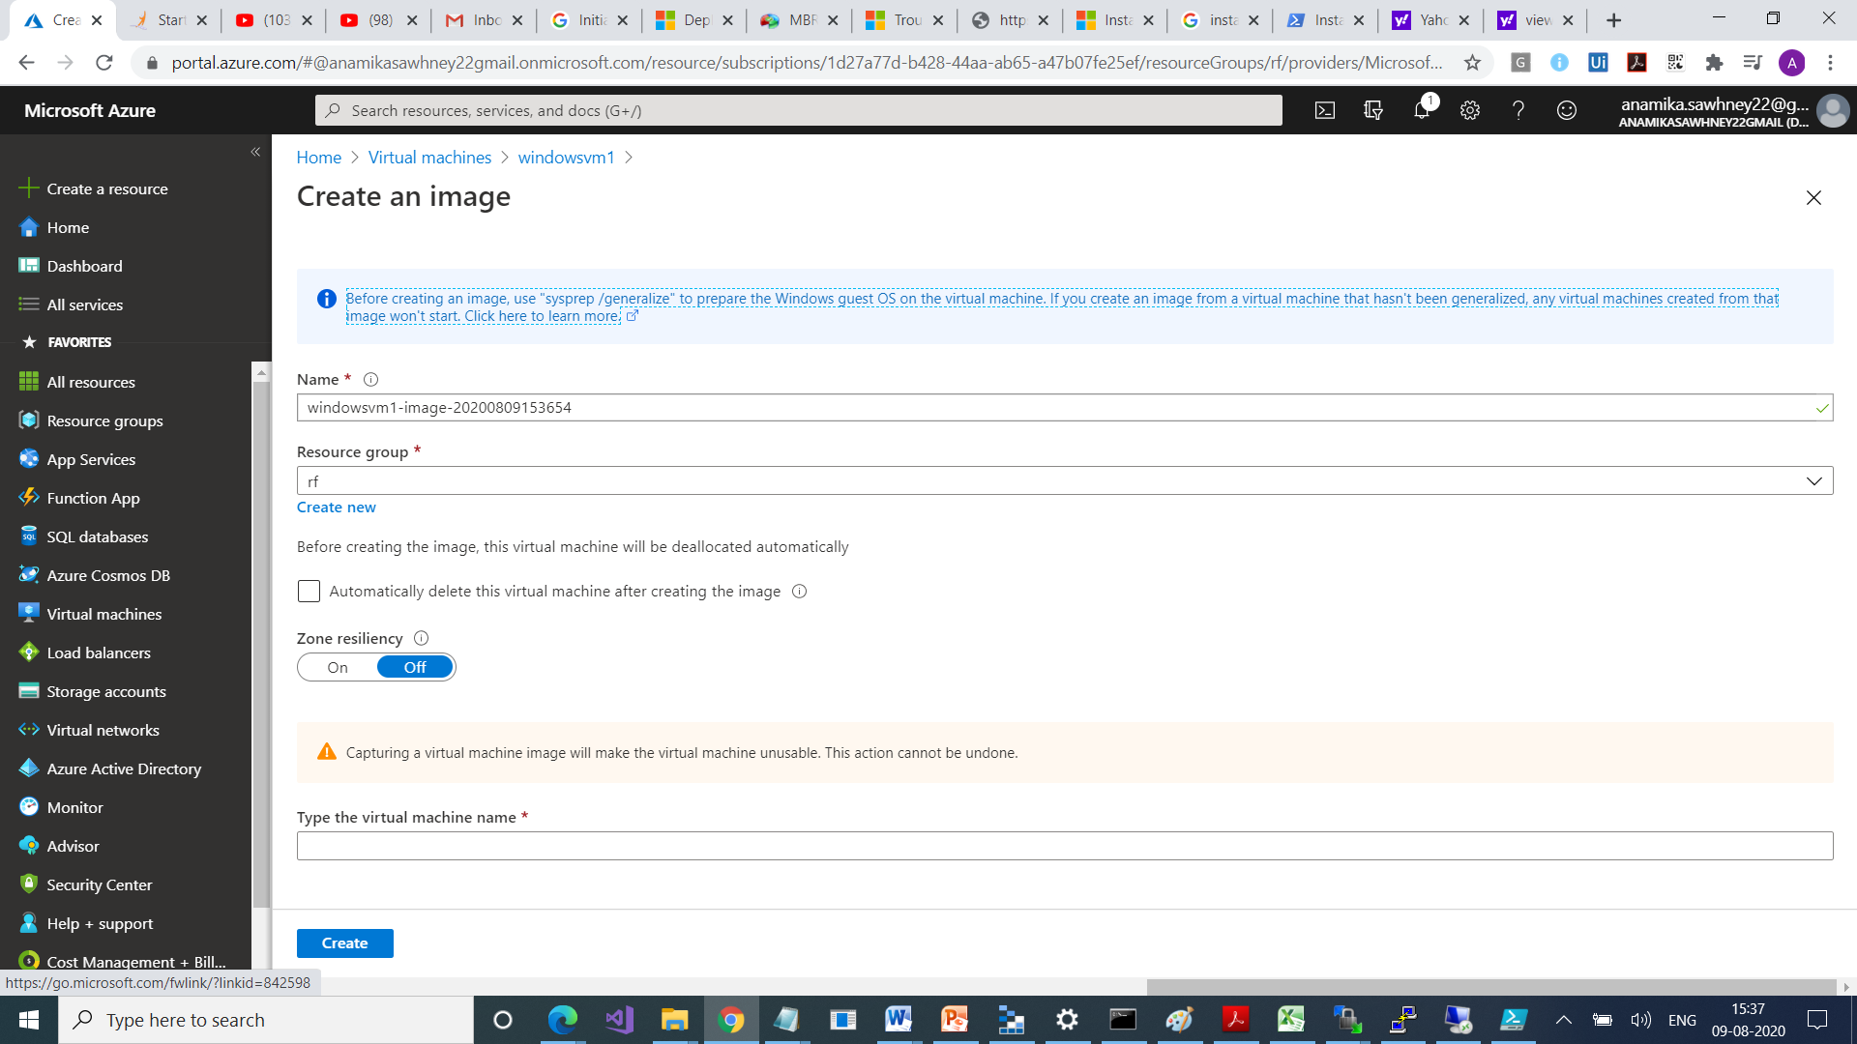

This is our VM

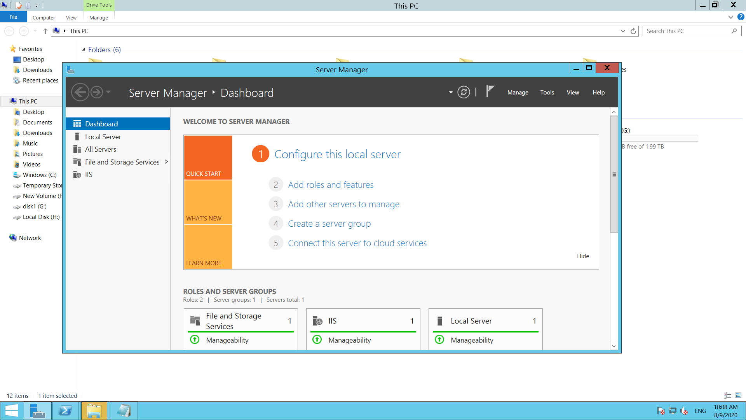

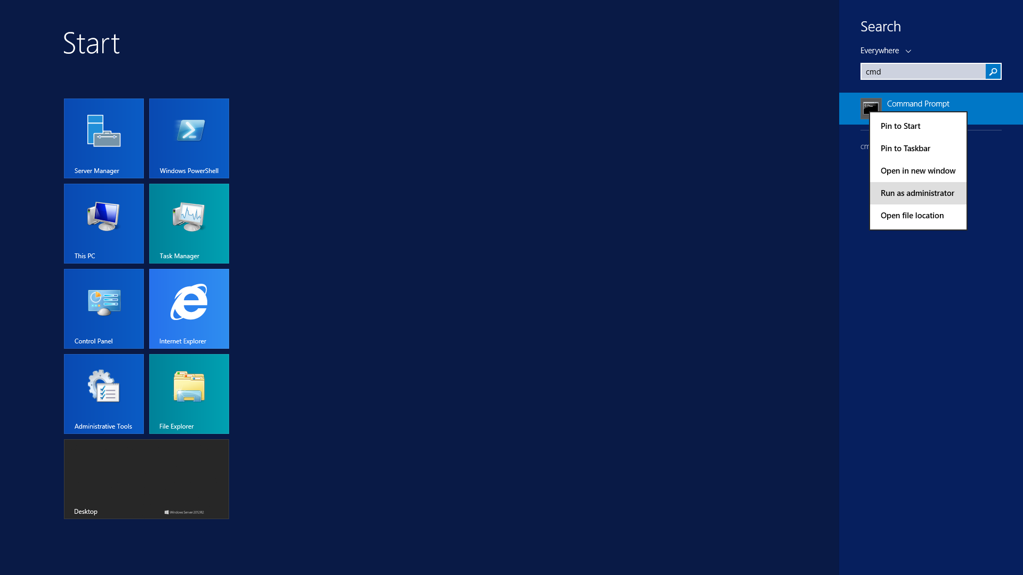

Run sysprep tool

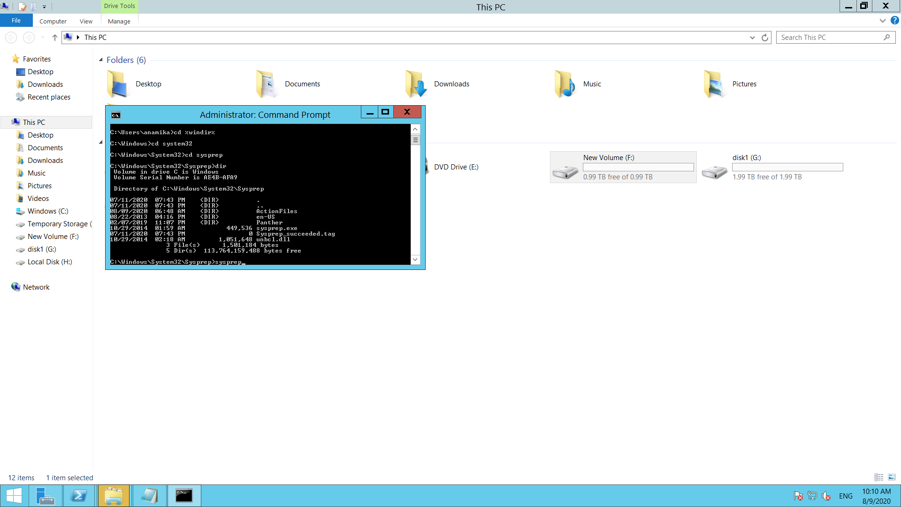

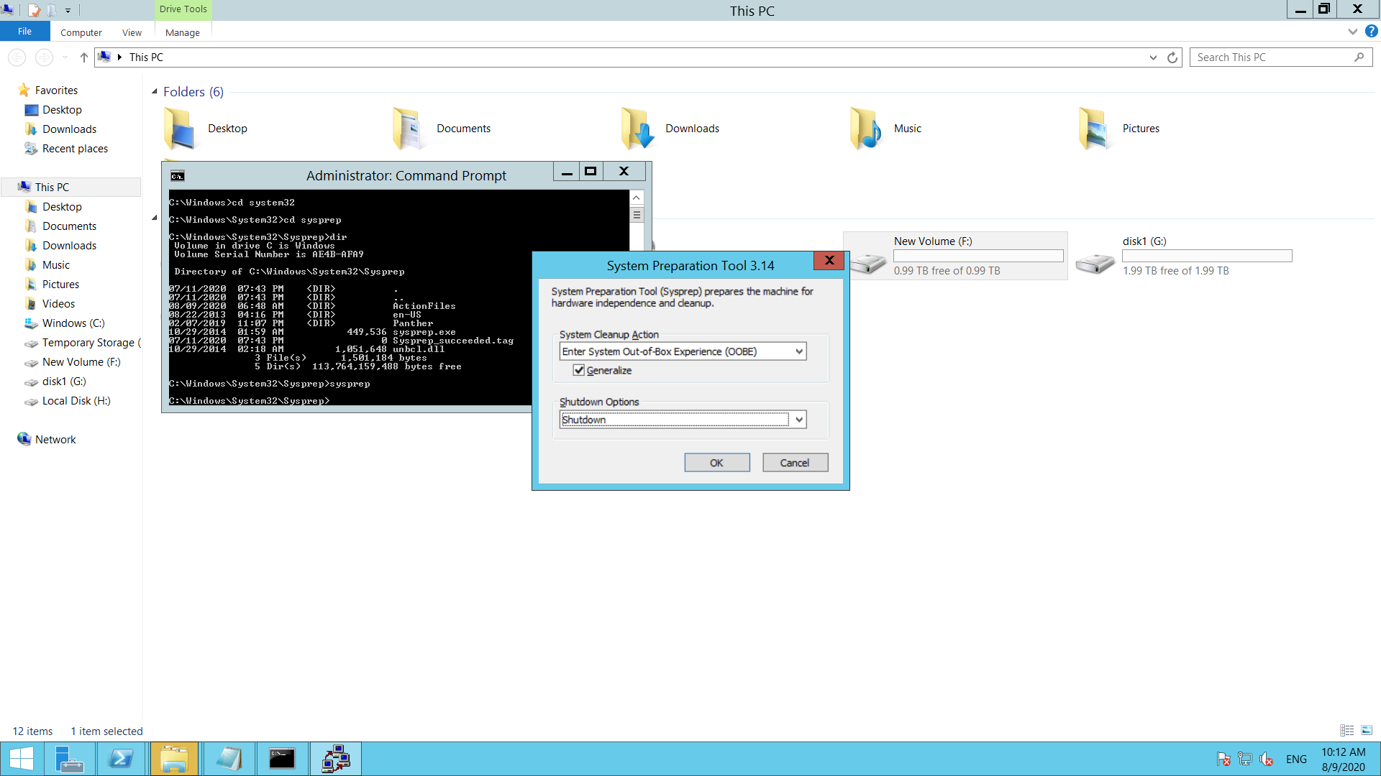

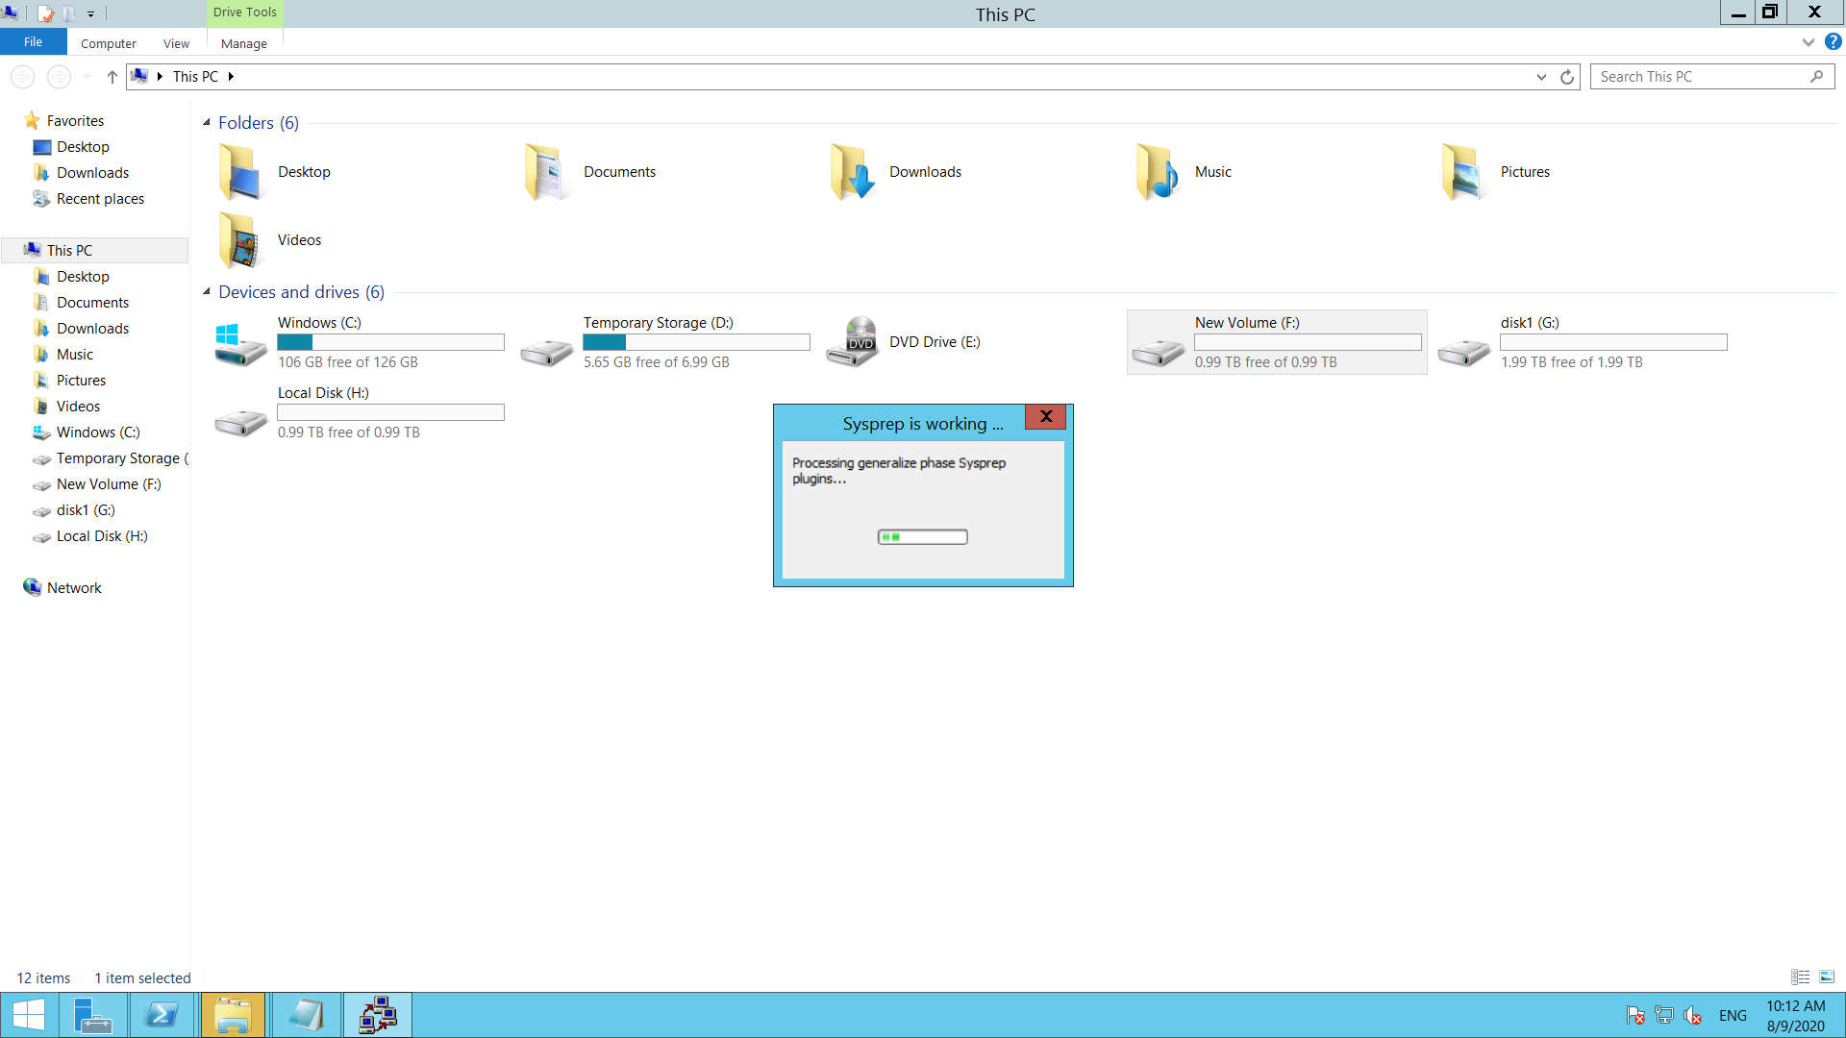



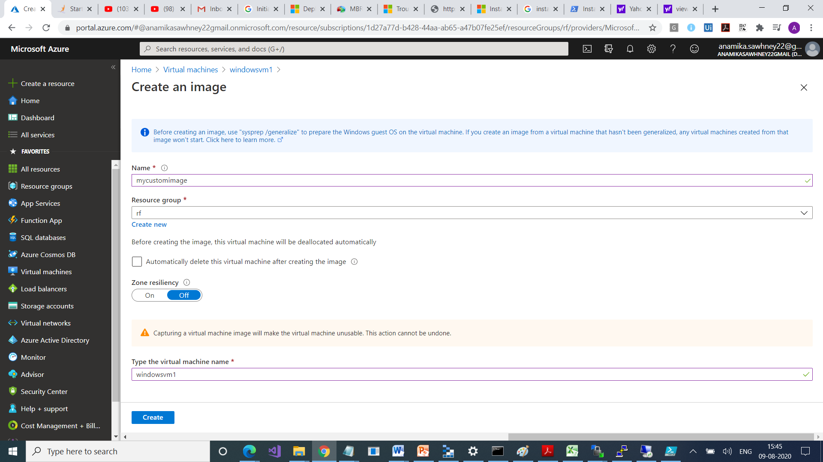

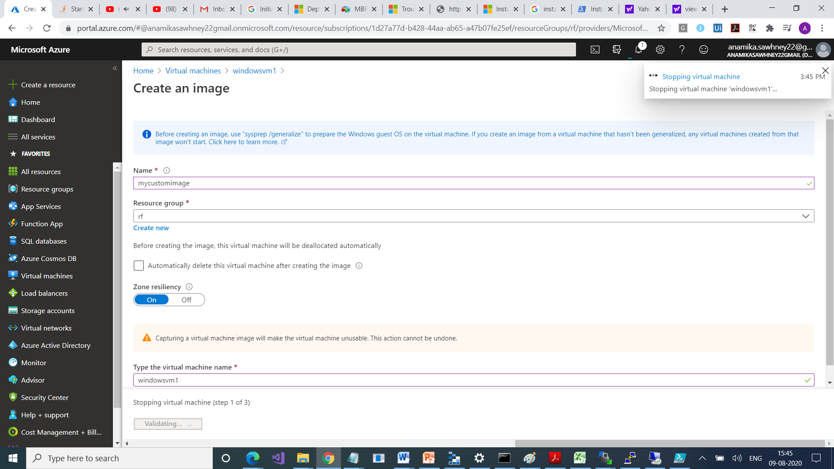

Its done

Autoscaling allows you to get required no. of your virtual machines on demand

It allows you to have right amount of resources running to handle the load on your application. It allows you to add resources to handle increase in load and also save money by reducing resources which are idle or getting less utilized.

You specify a minimum and max. no. of instances to run and add or remove VMs automatically based on a set of rules

Like for eg. If my CPU utilization > 80% n 2 VM’s add 1 more VM and distribute traffic on that VM too.

Limitations :

Min and Max no. of instances should not be same

Scale out > +

Scale in > -

Scaling

Horizontal > means increase or decrease no. of VMs according to situation

Vertical > keeps the same no. of VMs , but makes the VMs more or less powerful in terms of memory , CPU , speed and disk space. Requires VM to stop & restart

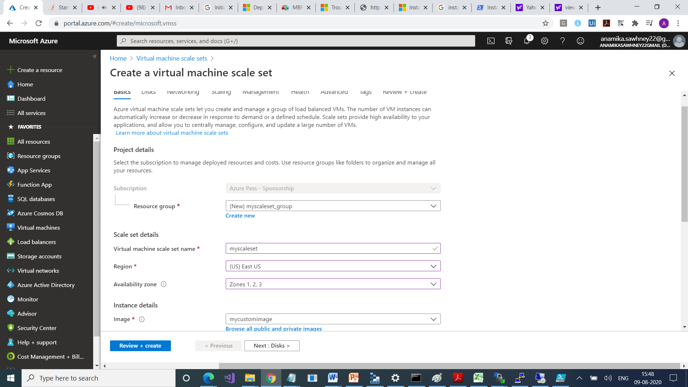 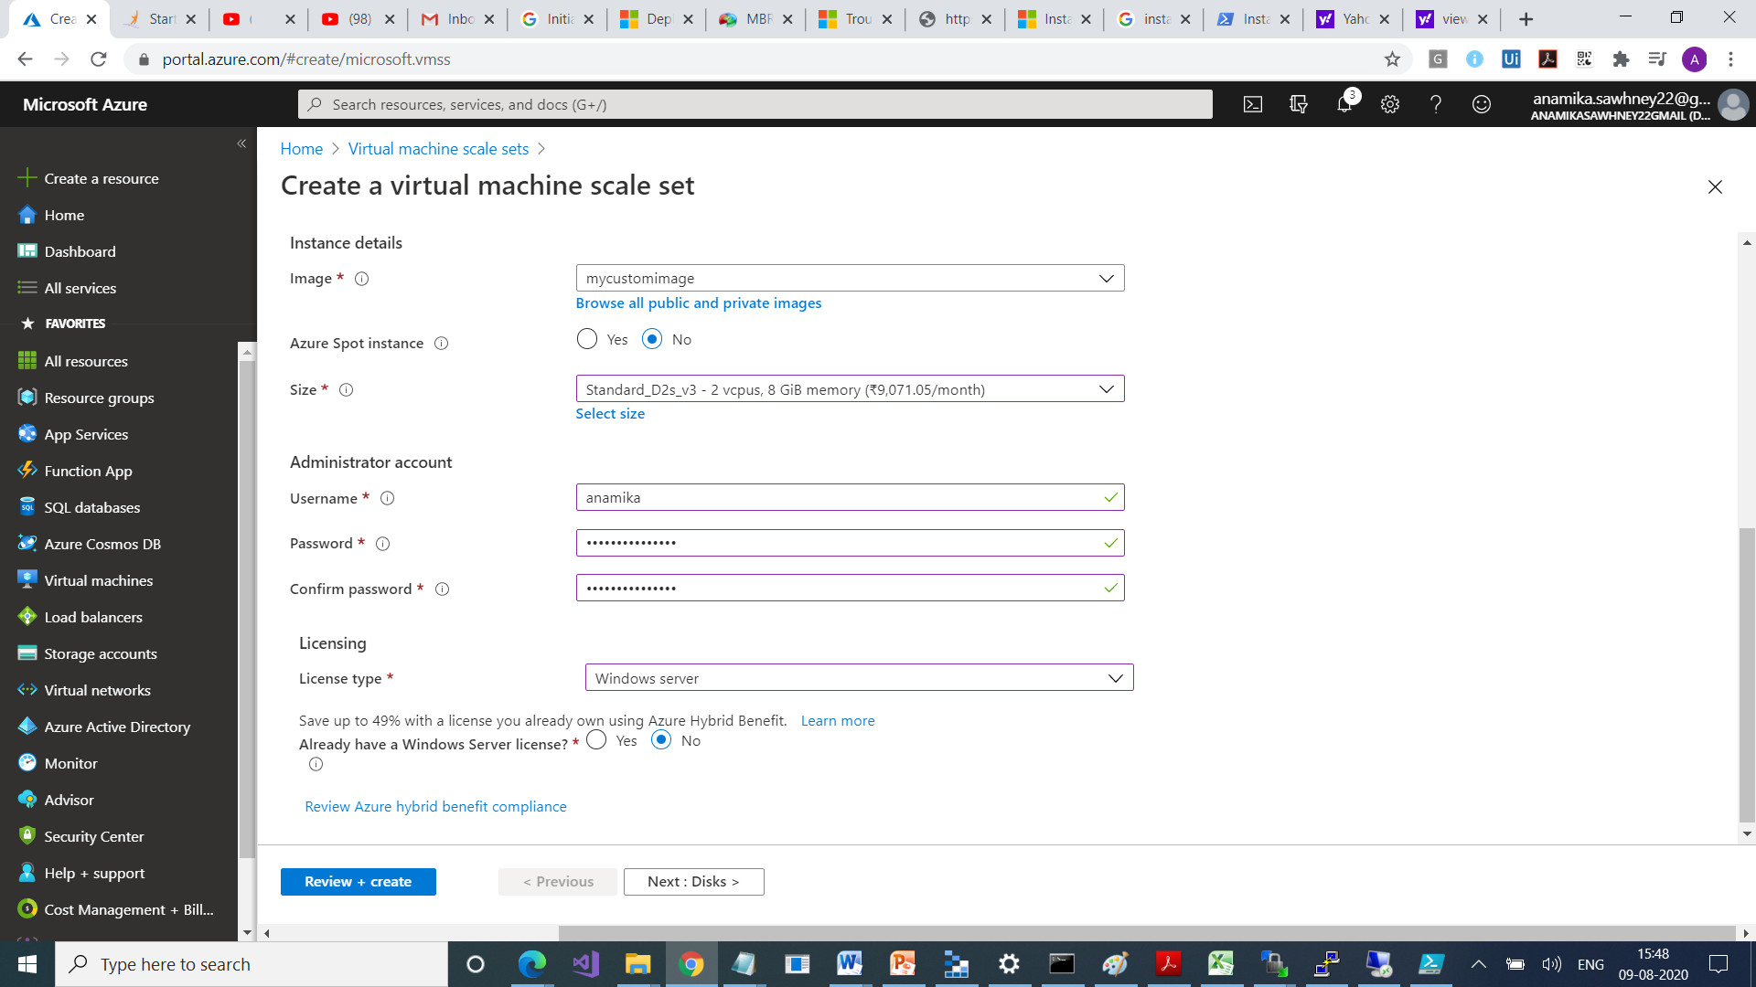

All Services > Compute > Virtual Machine Scale set > Create Virtual Machine Scale Set >

OS Disk Name > Server 2012 Data Centre, Resource Group > Location > Username > Password> Instance Count {0 - 1000} Instancse Size , AutoScaling = true

